S11_2420030685_ExperimentNo5_ExperimentName :-Git and GitHub

- Install Git on the system.
- Open Command Prompt or Git Bash.
- Create a new project folder.
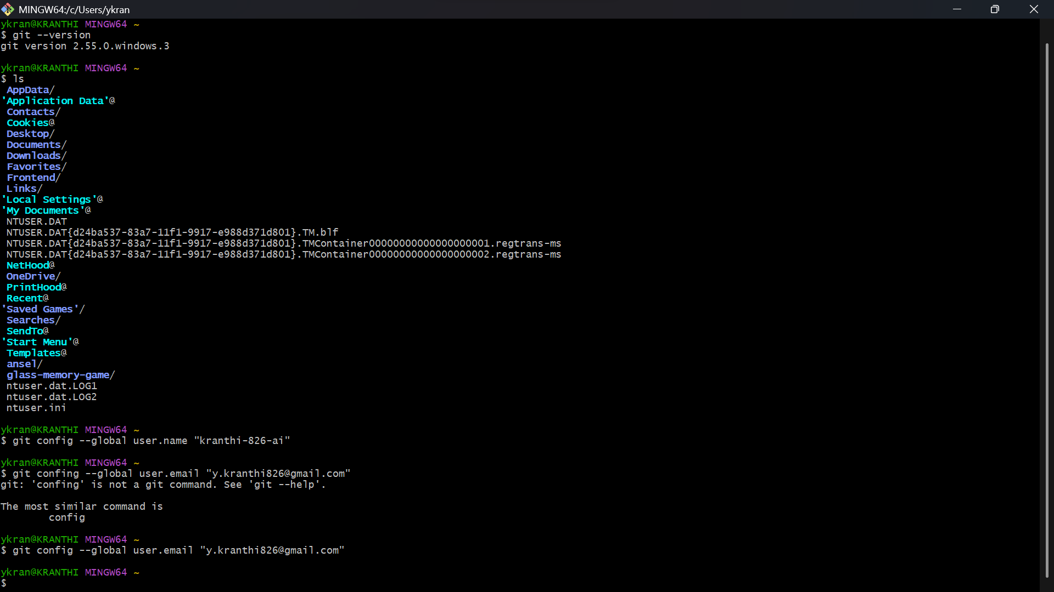
- Open the folder in the terminal.
- Initialize Git using git init.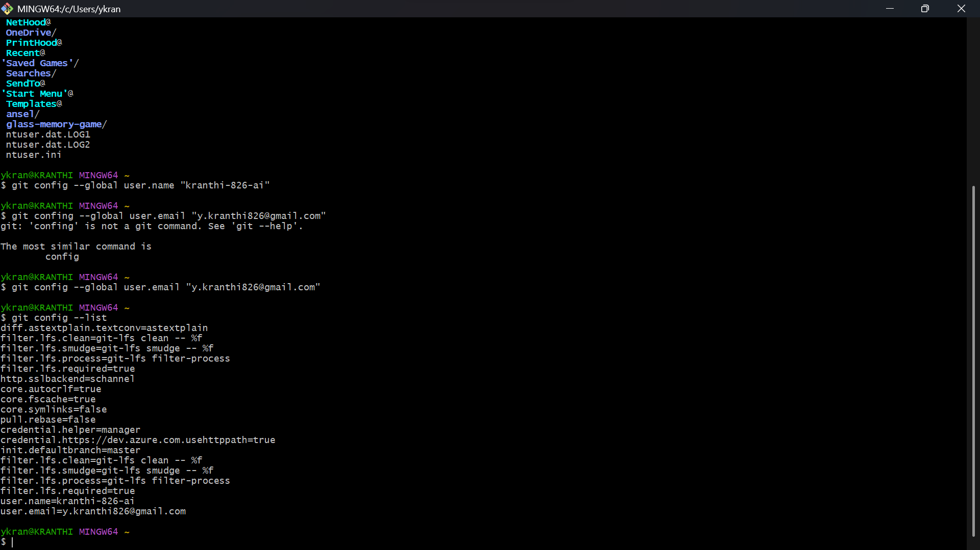
- Open the folder in the terminal.
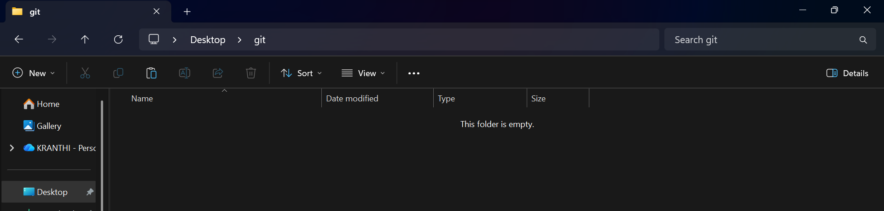
- Initialize Git using git init.
- Create or add project files.
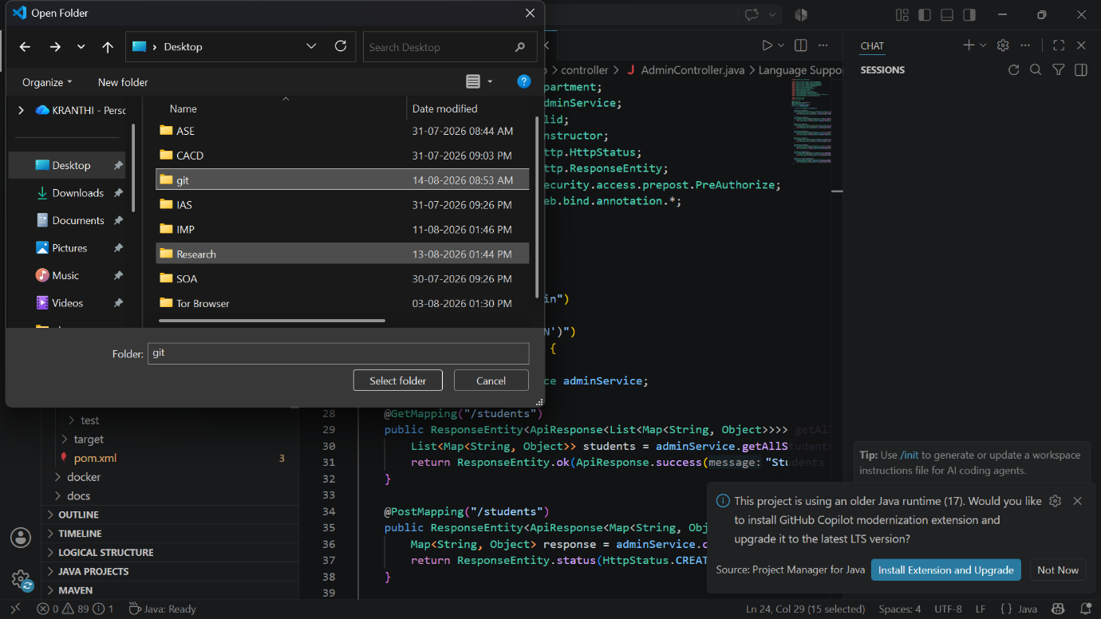
- Check the files using git status.

- Add the files using git add .
- Create a commit using git commit -m "Initial commit"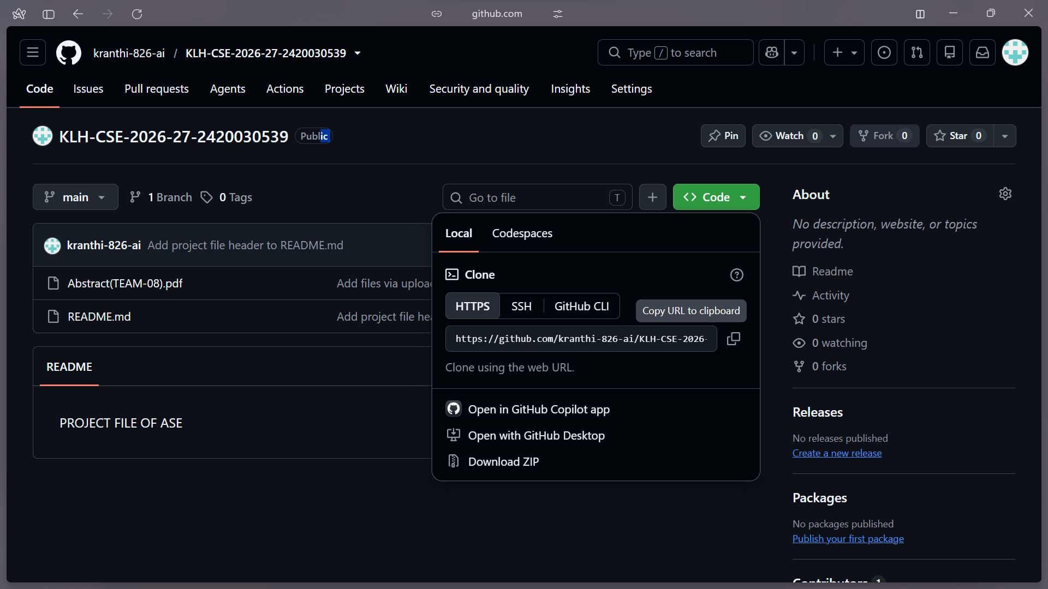Create a repository on GitHub.
- Connect the local repository with GitHub using git remote add origin.
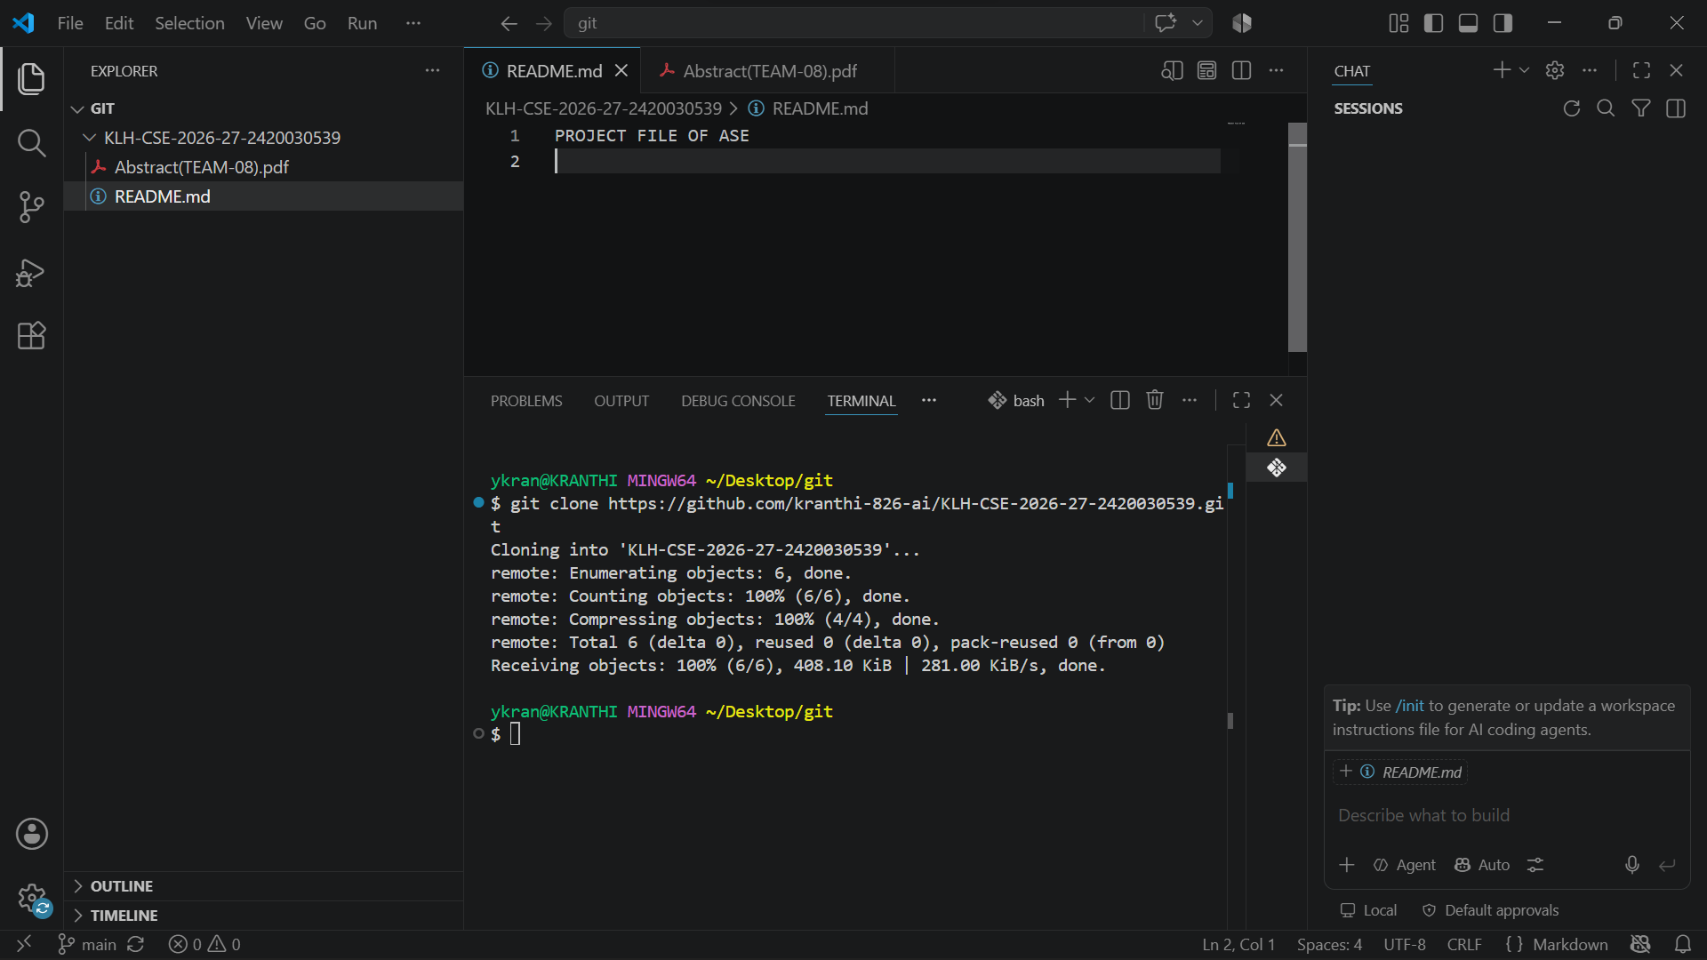

- Push the files using git push.
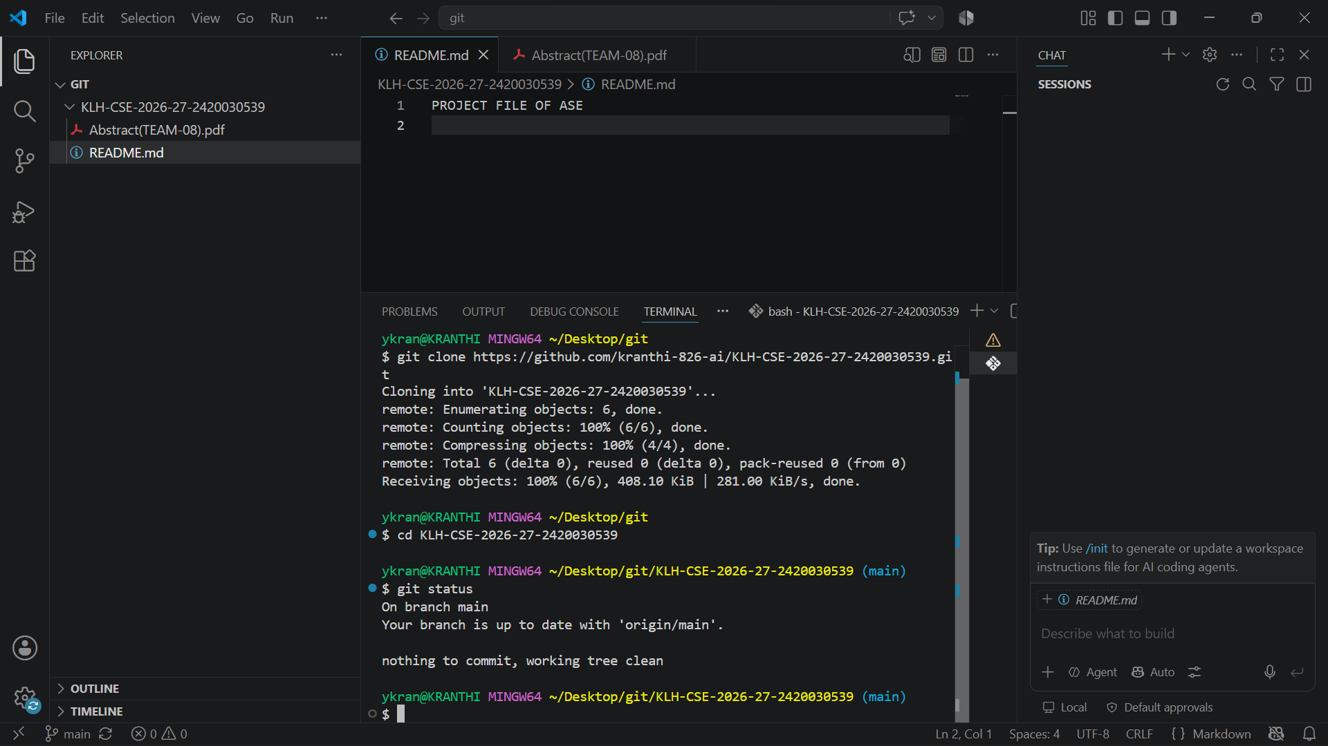
- Git status
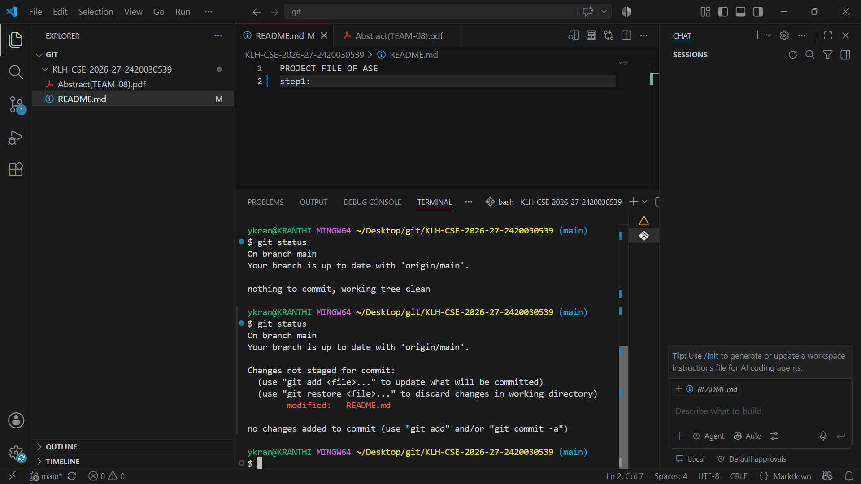
- Push the files using git push.
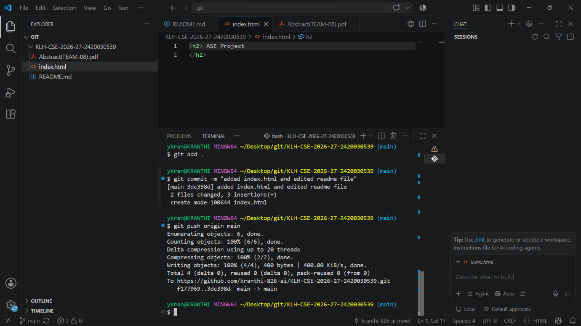
- Check the commits on GitHub.
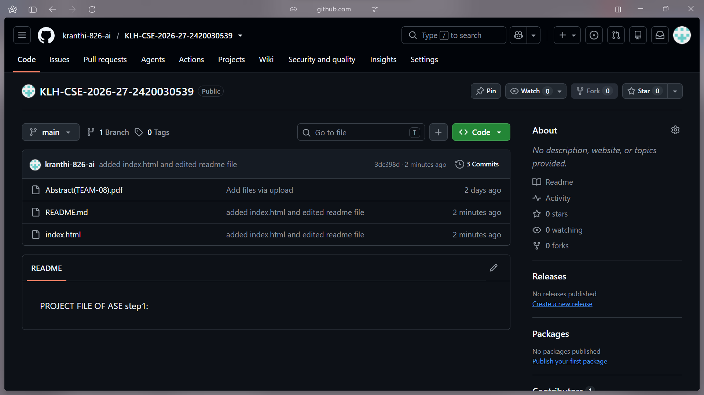
Outcome:
Successfully learned how to create Git commits and upload a project to GitHub.

